Bangladesh Medical Association (BMA)
List of Life Member-55
26. BMA Jhenaidah Branch

Sl No | Voter No | Voter Details
1 | Voter No  LM-2600001  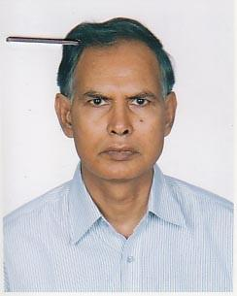 | DR. MD. ABDUL WAHAB  F/Name: Late Tamjab Biswas  M/Name:  BM & DC Reg. No:  NID:  Cell:  Address: 16-A, Green Road Dhaka  Blood Group: O+
2 | Voter No  LM-2600002  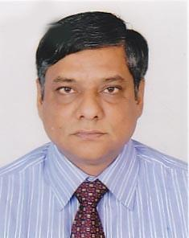 | DR. MD. MASUDUR RAHMAN  F/Name: Md. Ansar Uddin  M/Name:  BM & DC Reg. No:  NID:  Cell:  Address: Rahman Medical Centre, 82, Outer Circular Road, Bara Moghbazar, Dhaka  Blood Group:
3 | Voter No  LM-2600003  No Image | DR. SK. MUKHERJEE  F/Name:  M/Name:  BM & DC Reg. No:  NID:  Cell:  Address: Jhenidah  Blood Group:  E X P I R E D
4 | Voter No  LM-2600004  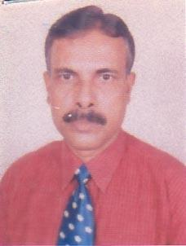 | DR. MD. HASANUZZAMAN  F/Name: Md. Golam Rahman  M/Name:  BM & DC Reg. No:  NID:  Cell:  Address: Hasan Clinic Shahid Mashiur Rahman Sarak Jhenidah  Blood Group:
5 | Voter No  LM-2600005  No Image | DR. MOHAMMAD ASHRAFUL ISLAM  F/Name:  M/Name:  BM & DC Reg. No:  NID:  Cell:  Address:  Blood Group:  TRANSFERED to BMA Dhaka City  LM-1405543
6 | Voter No  LM-2600006  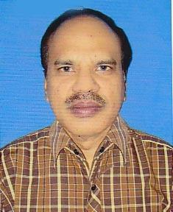 | DR. MD. SHAMSUL ISLAM  F/Name: Late Sayeed Uddin  M/Name:  BM & DC Reg. No:  NID:  Cell:  Address: Jr. Consultant Sadar Hospital Kushtia  Blood Group:
7 | Voter No  LM-2600007  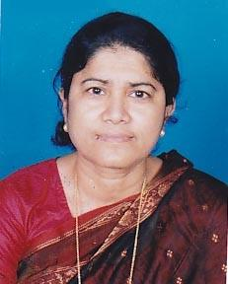 | DR. SHAMIMA SULTANA  F/Name: Md. Hazrat Ali Biswas  M/Name:  BM & DC Reg. No:  NID:  Cell:  Address: Medical Officer Thana Health Complex Sadar Hospital Jhenidah  Blood Group:
8 | Voter No  LM-2600008  No Image | DR. S.M. JAFOR ULLAH  F/Name:  M/Name:  BM & DC Reg. No:  NID:  Cell:  Address:  Blood Group:
9 | Voter No  LM-2600009  No Image | DR. MD. MAZIBUR RAHMAN  F/Name:  M/Name:  BM & DC Reg. No:  NID:  Cell:  Address:  Blood Group:  TRANSFERED to BMA Dhaka City  LM-1405543
10 | Voter No  LM-2600010  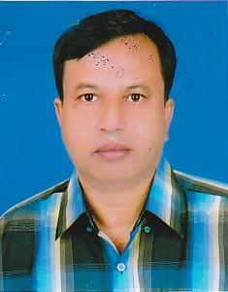 | DR. AYUB ALI  F/Name: Ahmad Ali  M/Name:  BM & DC Reg. No:  NID:  Cell:  Address: Medical Officer Thana Health Complex Meheshpur, Jhenaidah  Blood Group:
11 | Voter No  LM-2600011  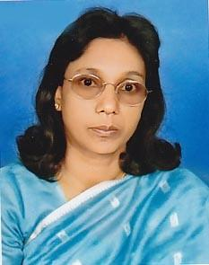 | DR. UMEE KULSUM  F/Name: Late Mohammad Ali  M/Name:  BM & DC Reg. No:  NID:  Cell:  Address: Hasan Clinic Shahid Mashiur Rahman Sarak Jhenidah  Blood Group:
12 | Voter No  LM-2600012  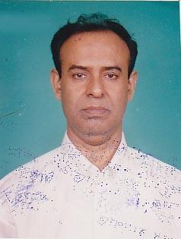 | DR. DULAL KUMAR CHAKRABORTY  F/Name: Late Dab Prashad Chakravarty  M/Name:  BM & DC Reg. No:  NID:  Cell:  Address: Radiologist Sadar Hospital Jhenidah  Blood Group:
13 | Voter No  LM-2600013  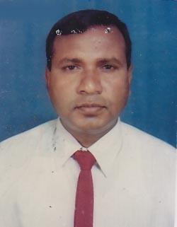 | DR. MD. ASLAM HOSSAIN  F/Name: Late Khoibar Rahman Biswas  M/Name:  BM & DC Reg. No:  NID:  Cell:  Address: Stadium Para Kali Sukanta Sorak Jhenidah  Blood Group:
14 | Voter No  LM-2600014  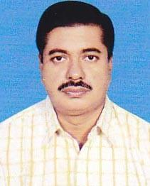 | DR. MD. NASIR UDDIN  F/Name:  M/Name:  BM & DC Reg. No:  NID:  Cell:  Address: a  Blood Group:
15 | Voter No  LM-2600015  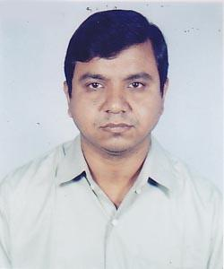 | DR. P.K. MANDAL  F/Name: Gobindo Chandra Mondol  M/Name:  BM & DC Reg. No:  NID:  Cell:  Address: Kaligang Bazar P.O.-Kaligang, Jhenidah.  Blood Group:
16 | Voter No  LM-2600016  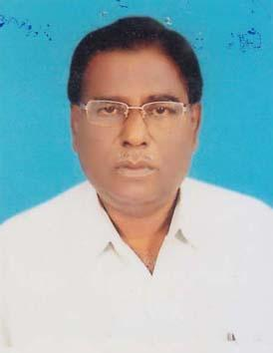 | DR. MD. AZIZIR RAHMAN  F/Name: Late. Khorshed Ali Biswas  M/Name: Lt Asiran Nessa  BM & DC Reg. No: 3749  NID: 4421902111146  Cell: 01711909203  Address: Mohila College Sarak, Po+Dt- Jhenaidah  Blood Group: B+
17 | Voter No  LM-2600017  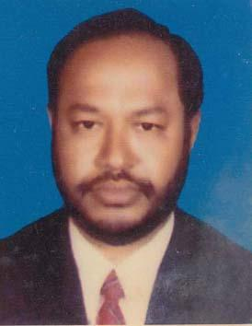 | DR. SHAIKH MOHD. AMINUL HAQUE  F/Name: Late Shaikh Mohd, Mozammel Haque  M/Name: Late Most. Amena Khatun  BM & DC Reg. No: 10958  NID: 4421909165657  Cell: 01711117531  Address: Asstt. Director, Dghs, Mohakhali, Dhaka, Attached Mats, Jhenidah  Blood Group: O+
18 | Voter No  LM-2600018  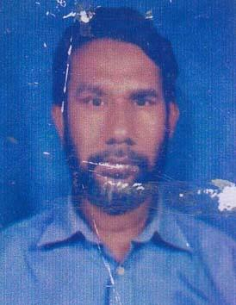 | DR. MD. EMDADUL HAQUE  F/Name: Md. Abul Hossain  M/Name: Mrs. Sahida Khatun  BM & DC Reg. No: 17112  NID: 4121105967046  Cell: 01712253665  Address: Senior Consultent (Gynae & Obst) Sador Hospital, Jhenaidah  Blood Group: O+
19 | Voter No  LM-2600019  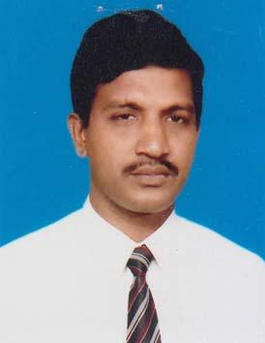 | DR. A. S. M. ABDUR RAHMAN  F/Name: Munshi Abdul Muttalib  M/Name: Mrs. Sufia Khatun  BM & DC Reg. No: 15712  NID: 4421906147029  Cell: 01711029346  Address: H. S. S. Road, Jhenidah Sador  Blood Group: O+
20 | Voter No  LM-2600020  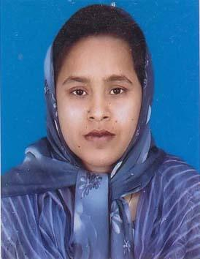 | DR. NAZNIN ARA KHANOM  F/Name: Md. Rahmat Ullah Biswas  M/Name: Late- Parrizan Nessa  BM & DC Reg. No: 23062  NID: 4421906147031  Cell: 01716248070  Address: H.S.S. Road, Jhenidah Sador  Blood Group:
21 | Voter No  LM-2600021  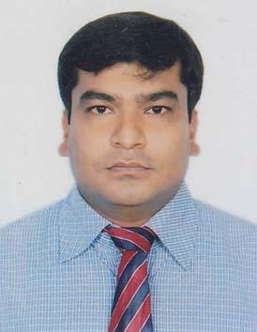 | DR. MD. MOZZAMMEL HAQUE  F/Name: Late : Khoshal Biswas  M/Name: Ms. Shukjan Nessa  BM & DC Reg. No: 31235  NID: 2693014491180  Cell: 01711158549  Address: EMO, Sadar Hospital, Jhenidah  Blood Group: A+
22 | Voter No  LM-2600022  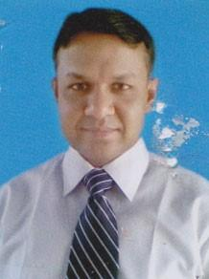 | DR. ZAHIDUR RAHMAN  F/Name: Late Dobir Uddin Biswas  M/Name: Mrs. Kamala Begum  BM & DC Reg. No: 31236  NID: 4421905139060  Cell: 01711570764  Address: 230, Sher-E-Bangla Sarak Jhenidah  Blood Group: A+
23 | Voter No  LM-2600023  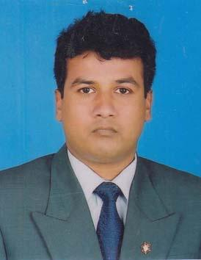 | DR. MD. ABDUL MOTIN  F/Name: Md. Samser Ali Mondol  M/Name: Mst. Jobiron Nessa  BM & DC Reg. No: 37562  NID: 4421905132560  Cell: 01712567290  Address: Asistant Surgeon, Holidhani Union Sub Center, Sodor Upazilla, Jhenidah (Ahachment-MATS, Jheidah)  Blood Group: B+
24 | Voter No  LM-2600024  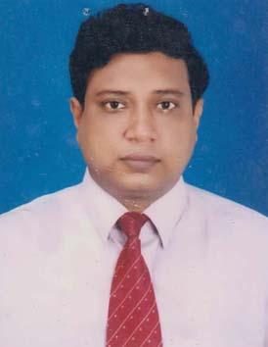 | DR. MASUD AHMED SOHEL  F/Name: Late Abul Hussain  M/Name: Jamila Khatun  BM & DC Reg. No: 28011  NID: 4421905133920  Cell: 01711150513  Address: Diabetic Hospital, Jhenidah  Blood Group: O+
25 | Voter No  LM-2600025 | DR. ALI HASAN FARID  F/Name: Md. Mosharof Hossain  M/Name: Farida Begum  BM & DC Reg. No: 46768  NID: 2690243739723  Cell: 01914752585  Address: Sadar Hospital, Jhenidah  Blood Group: A+
26 | Voter No  LM-2600026 | DR. MD. MONIRUL ISLAM  F/Name: Md. Hanef Ali  M/Name: Sufia Khatun  BM & DC Reg. No: 52458  NID: 4798516214986  Cell: 01717250254  Address: C/O, MD. AliBurdin, Mollapara, Hamdah, Jhenaidah  Blood Group: B+
27 | Voter No  LM-2600027  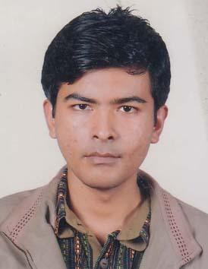 | DR. SAUMITRA CHAKRAVARTY  F/Name: Dr. Dulal Kumar Chakravarty  M/Name: Saraswati Rani Roy  BM & DC Reg. No: 58452  NID: 6125217231265  Cell: 01816653358  Address: Flat- 5/E, House-2/H/1, Sundarban Holdings, Road-1, Beside Shyamoli Overbridge, Dhaka  Blood Group: A-
28 | Voter No  LM-2600028  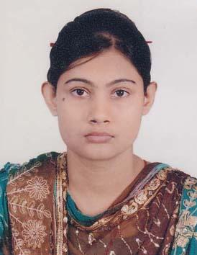 | DR. SHUVRA CHAKRABORTY  F/Name: Basudev Chakraborty  M/Name: Latika Goswami  BM & DC Reg. No: 53890  NID: 9326602050782  Cell: 01832202331  Address: Flat 5/E, House- 2/H/1, Sundarban Holdings, Road-1, Beside Shyamoli Overbridge, Dhaka  Blood Group: O+
29 | Voter No  LM-2600029  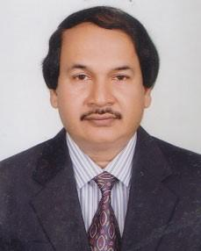 | DR. A.K.M. KAMAL  F/Name: Kaji Abdul Qayum  M/Name: Syeda Hasina Mihir  BM & DC Reg. No: 15957  NID: 4421909164573  Cell: 01716698369  Address: Junior Consultant, Cardiology, Sadar Hospital Jhenidah  Blood Group: O+
30 | Voter No  LM-2600030  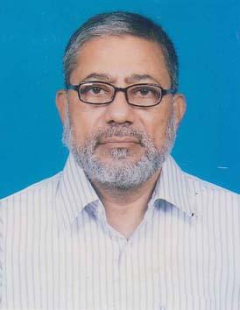 | DR. MD. ABDUL LATIF  F/Name: Late Keamuddin Ahmed  M/Name: Late Marium Nessa  BM & DC Reg. No: 8988  NID: 4421902110364  Cell: 01711803009  Address: Stadium Para, Jhenaidah  Blood Group: O+
31 | Voter No  LM-2600031  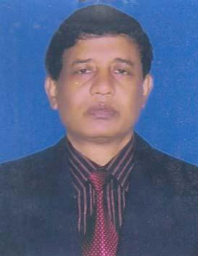 | DR. MD. ABDUL KHALEQUE  F/Name: Late Akbor Ali Mollah  M/Name: Mrs. Mohela Khatun  BM & DC Reg. No: 12972  NID: 4421908158793  Cell: 01711183751  Address: Taslim Clinic Kabi Golam Mostafa Road, Jhenaidah  Blood Group: B+
32 | Voter No  LM-2600032  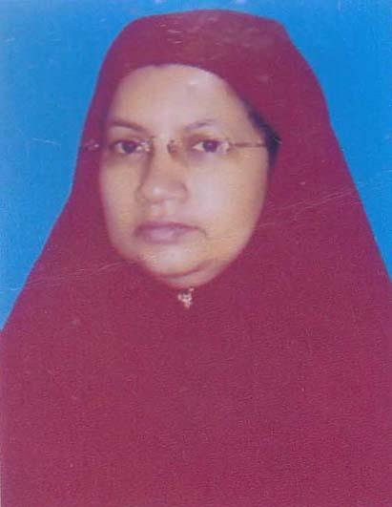 | DR. TANJUARA TASLIM  F/Name: Md. Alhaj- Nur Ali Mia  M/Name: Mrs. Alhaj- Sokhina Begum  BM & DC Reg. No: 18100  NID: 4424908158796  Cell: 01717240826  Address: C/O-Dr. Md. Abdul Khalaque Kobi Golam Mostofa Shorok, Jhenidah  Blood Group: B+
33 | Voter No  LM-2600033  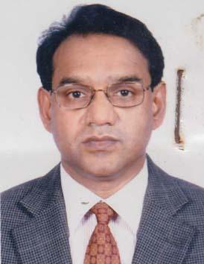 | DR. MD. FAZLUL HOQUE  F/Name: Golam Mohammod  M/Name: Fatema Begum  BM & DC Reg. No: 10336  NID: 2619551957368  Cell: 01711532470  Address: Square Hospital Ltd. 18/F B.R Uttam Qazi Nuruzaman Sarak  Blood Group: O+
34 | Voter No  LM-2600034  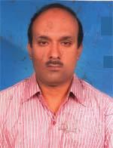 | DR. MD. RABIUL HASAN  F/Name: Md. Sirajul Islam  M/Name: Mst. Monoara Begum  BM & DC Reg. No: 26363  NID: 4411973268223  Cell: 01711011210  Address: U.H.F.P.O, Horinakundu, Jhenaidah  Blood Group: O+
35 | Voter No  LM-2600035  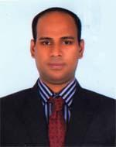 | DR. SULTAN AHMED  F/Name: Md. Tojammel Biswas  M/Name: Hena Khatun  BM & DC Reg. No: 61197  NID: 4798516214716  Cell: 01722896579  Address: Vill-Paik Para, Post-Naldanga, Thana-Kaligonj, Dist-Jhenidah  Blood Group: B+
36 | Voter No  LM-2600036  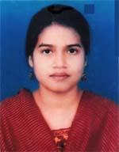 | DR. KHURSHID NAZNIN  F/Name: Md. Golam Sarowar  M/Name: Late Momotaz Begum  BM & DC Reg. No: 53269  NID: 4423303429525  Cell: 01712911845  Address: Vill-Faila, Post-Naldanga, Thana-Kaligonj, Dist-Jhenaidah  Blood Group: A+
37 | Voter No  LM-2600037  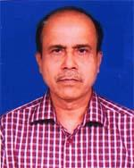 | DR. PROVASH KUMAR DAS  F/Name: Late Harisankar Das  M/Name: Urmila Rani Das  BM & DC Reg. No: 16060  NID: 4424203586966  Cell: 01711047056  Address: U.H.C Kotchandpur, Jhenaidah  Blood Group: B+
38 | Voter No  LM-2600038  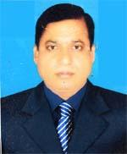 | DR. MD. TAHAZZEL HOSSAIN  F/Name: Late Altaf Hossain  M/Name: Late Kodbanu  BM & DC Reg. No: 16031  NID: 4427106078526  Cell: 01712523153  Address: Upazilla Health and Family Planning officer, Moheshpur, Jhenaidah  Blood Group: O+
39 | Voter No  LM-2600039  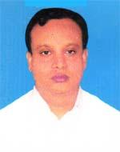 | DR. MD. RASHED AL MAMUN  F/Name: Late Sukur Ali Mia  M/Name: Mst. Ulfatun Nessa  BM & DC Reg. No: 38609  NID: 2627205298023  Cell: 01712681701  Address: Kalikapur Sarak, Adorshopara, Jhenaidah  Blood Group: O+
40 | Voter No  LM-2600040  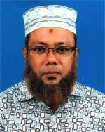 | DR. MUNSHI MD. REZA SEKENDER  F/Name: Late Sekender Ali Munshi  M/Name: Late Rabeya Begum  BM & DC Reg. No: 16444  NID: 4421905131485  Cell: 01716280708  Address: Fatema Monjil 103/17, Bapari Para, Jhenaidah  Blood Group: B+
41 | Voter No  LM-2600041  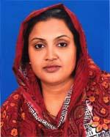 | DR. RASHEDA SULTANA  F/Name: Late Abdur Rashid  M/Name: Late Anjuman Ara Begum  BM & DC Reg. No: 18349  NID: 4421904123860  Cell: 01711195754  Address: UHPFFO, Sadar Upazilla, Jhenaidah  Blood Group: AB+
42 | Voter No  LM-2600042 | DR. MD. ANOWARUL ISLAM  F/Name: A. K. M Moksudur Rahman  M/Name: Muslima Khanom  BM & DC Reg. No: 34342  NID: 442190412351  Cell: 01720141195  Address: Medical Officer, Civil Surgeon office, Jhenaidah  Blood Group: O+
43 | Voter No  LM-2600043  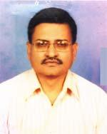 | DR. JAHID AHMED  F/Name: Dr. Nasir Uddin Ahmed  M/Name: Mrs. Mahmuda Begum  BM & DC Reg. No: 19527  NID: 441906146121  Cell: 01711901799  Address: 52, Gitanjali Road, Jhenaidah-7300  Blood Group: O+
44 | Voter No  LM-2600044  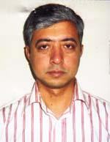 | DR. TARIQ AKHTER KHAN  F/Name: Mustafizur Rahman Khan  M/Name: Nadira Akhter  BM & DC Reg. No: 31322  NID: 4421909165171  Cell: 01717659303  Address: BSMMU, Dhaka  Blood Group: O+
45 | Voter No  LM-2600045  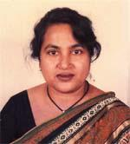 | DR. KAZI HAMIDUN NESSA PAKHI  F/Name: Late Kazi Abdul Gafur  M/Name: Late Rahimun Nessa  BM & DC Reg. No: 20859  NID: 19644421902109528  Cell: 01711177673  Address: 138, Kobi Sukanto Sarak, Jhenaidah  Blood Group: B+
46 | Voter No  LM-2600046  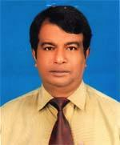 | DR. NURULLAH MUHAMMAD  F/Name: Abdur Rouf  M/Name: Jamila Khatun  BM & DC Reg. No: 6604  NID: 4421905139141  Cell: 01716203709  Address: No. 3, Shere Bangla Sarak, Humdhah , Jhenaidah  Blood Group: B+
47 | Voter No  LM-2600047 | DR. MD. TASNIMUL KHAIR SHOVON  F/Name: Dr. Md. Abdul Khaleque  M/Name: Dr. Tanjura Taslim  BM & DC Reg. No: 63041  NID: 4798516216410  Cell: 01715534884  Address: 5, Kobi Golam Mostafa Road, Modon Mohon Para, Jhenaidah  Blood Group: B+
48 | Voter No  LM-2600048  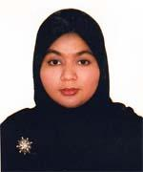 | DR. IFRAD TASNIM  F/Name: Prof. Dr. Israil Biswas  M/Name: Dr. Rehana Sultana  BM & DC Reg. No: 63040  NID: 4798520287097  Cell: 01731434357  Address: 5, Kobi Golam Mostafa Road, Modon Mohon Para, Jhenaidah Sadar, Jhenaidah  Blood Group: B+
49 | Voter No  LM-2600049  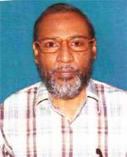 | DR. A. B. M. SIDDIQUL ISLAM  F/Name: Late Ahmed Ali  M/Name: Late Khodeza Khatun  BM & DC Reg. No: 7574  NID: 2694812092792  Cell: 01711330807  Address: 32, Moulana Bhasani Road, Shamima Clinic, Jhenaidah  Blood Group: O+  E X P I R E D
50 | Voter No  LM-2600050  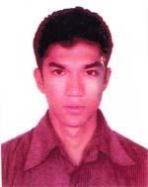 | DR. MEHEDI ISLAM TITU  F/Name: Md. Siddiqul Islam  M/Name: Shamima Sultana  BM & DC Reg. No: 71564  NID: 19902694812000915  Cell: 01797104359  Address: Shamima Clinic Road, Thana-Jhenidah Sadar  Blood Group: B+
51 | Voter No  LM-2600051 | DR. ASHIFA ASHRAFEE  F/Name: Md. Ali Ashraf  M/Name: Rozy Ashraf  BM & DC Reg. No: 71541  NID: 19917625507000100  Cell: 01761058708  Address: 1/F, North East Darus Salam Road, Mirpur-1, Dhaka  Blood Group: B+
52 | Voter No  LM-2600052  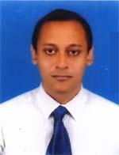 | DR. MD. ZAHIDUL HASAN  F/Name: Md. Moazzem Hosain  M/Name: Fatema Johora  BM & DC Reg. No: 62864  NID: 19894798516216463  Cell: 01752009041  Address: Arappur, Jhenaidah  Blood Group: O+
53 | Voter No  LM-2600053  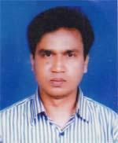 | DR. MD. ALAUDDIN  F/Name: Md. Ishaque Ali  M/Name: Mrs Nurjahan Begum  BM & DC Reg. No: 24561  NID: 5728706117020  Cell: 01716883040  Address: Sadar Hospital, Jhenaidah  Blood Group: O+
54 | Voter No  LM-2600054 | DR. ARIF AHMED  F/Name: Md. Fazlul Karim  M/Name: Zakia Karim  BM & DC Reg. No: 51223  NID: 2692848054575  Cell: 01712195887  Address: 10/5, Kobi Shokanto Sharak, Steadium Para, Jhenaidah  Blood Group: B+
55 | Voter No  LM-2600055  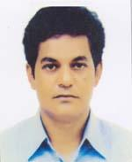 | DR. SHYAMAL KUMAR BISWAS  F/Name: Jugal Kishore Biswas  M/Name: Namita Rani Das  BM & DC Reg. No: 23431  NID: 4421905136390  Cell: 01710875955  Address: OGSB, Halcyon Heights, Plot-2/3, Flat-A3, Block-A, Mirpur Road, Mohammad Pur, Dhaka  Blood Group: B+

